DATA HANDLING AND VISUALIZATION
IDENTIFY SKEWNESS USING VIOLIN PLOTS | SLOT D
Name Manisha M | Roll No. 24 | Registration No. 192424130
QUESTION PAPER
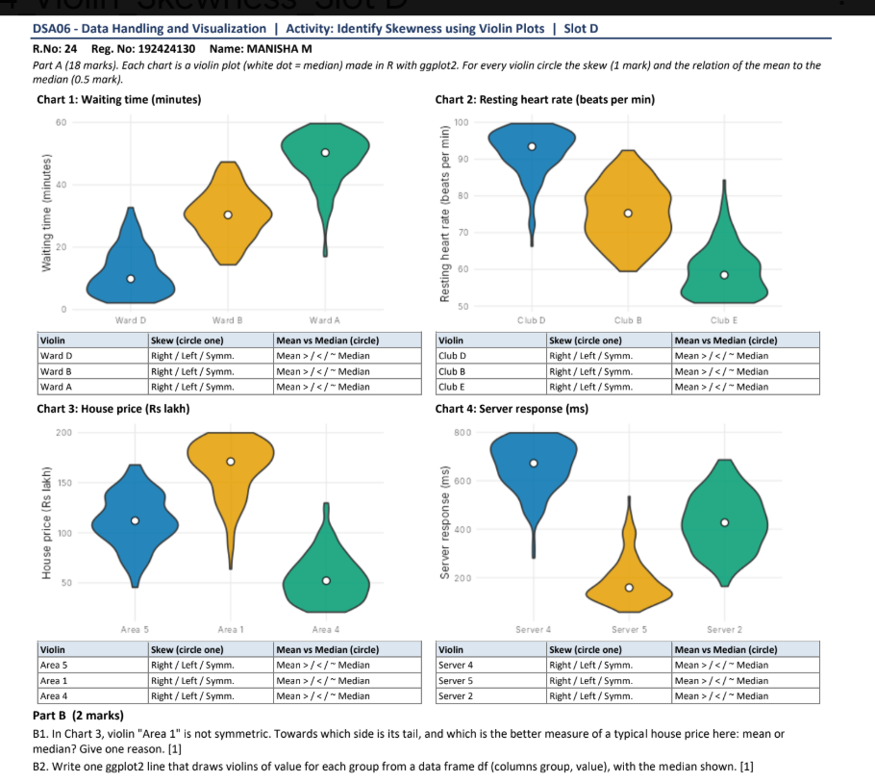

Answer Key
A violin’s longer, thinner extension shows the direction of its tail. A longer tail toward larger values indicates right skew; a tail toward smaller values indicates left skew. For a right-skewed distribution, the mean is generally above the median; for a left-skewed distribution, it is generally below. A roughly balanced violin suggests symmetry and a mean close to the median.

Part A Skew and center

Chart 1 Waiting time
Group | Skew | Mean vs median | Reason from the violin
Ward D | Right | Mean > median | Long tail extends toward larger waiting times.
Ward B | Symmetric | Mean ≈ median | The violin is approximately balanced around its center.
Ward A | Left | Mean < median | Long tail extends toward smaller waiting times.

Chart 2 Resting heart rate
Group | Skew | Mean vs median | Reason from the violin
Club D | Left | Mean < median | The longer tail reaches toward lower heart rates.
Club B | Symmetric | Mean ≈ median | The shape is approximately balanced on both sides.
Club E | Right | Mean > median | The longer tail reaches toward higher heart rates.

Chart 3 House price
Group | Skew | Mean vs median | Reason from the violin
Area 5 | Symmetric | Mean ≈ median | The distribution is roughly balanced around its center.
Area 1 | Left | Mean < median | Most density is high, with an extended tail toward lower prices.
Area 4 | Right | Mean > median | The distribution extends farther toward higher prices.

Chart 4 Server response
Group | Skew | Mean vs median | Reason from the violin
Server 4 | Left | Mean < median | The violin has a longer extension toward lower response times.
Server 5 | Right | Mean > median | A thin tail extends toward higher response times.
Server 2 | Symmetric | Mean ≈ median | The spread is roughly balanced around the median.
Note. Skew is identified from the direction of the tail, not from which side of the axis has the larger numerical values. The mean–median relationships are qualitative expectations based on the displayed shapes.

Part B Short answers and R code

B1 Typical house price in Area 1
The tail points toward the lower house prices, so Area 1 is left-skewed. The median is the better measure of a typical price because it is less affected by the small number of unusually low values in the tail.

B2 Violin plot with a median marker
This one-line ggplot2 expression draws one violin for each group and places a white point at that group’s median:
ggplot(df, aes(x = group, y = value)) + geom_violin() + stat_summary(fun = median, geom = "point", shape = 21, fill = "white")

Reproducible example and output
The question does not provide the values in df, so the figure below is an illustrative output from a small demonstration data set. The plot structure and median marker match the requested code.
library(ggplot2)
set.seed(24)
df <- data.frame(
group = rep(c("Group A", "Group B", "Group C"), each = 110),
value = c(rnorm(110, 5, 0.8), rnorm(110, 7.2, 1.05),
rnorm(110, 4.2, 0.55))
)
ggplot(df, aes(x = group, y = value)) + geom_violin() +
stat_summary(fun = median, geom = "point", shape = 21, fill = "white")
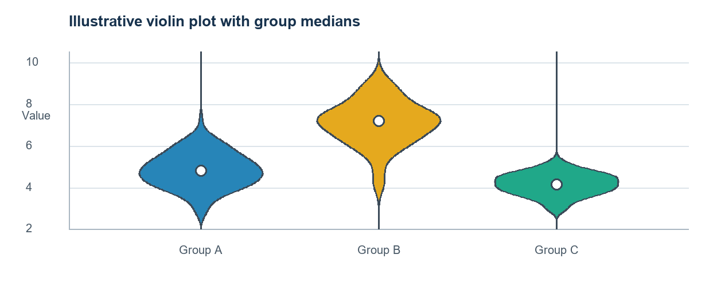
Illustrative output: each white point marks the group median. Actual violins depend on the values supplied in df.

